**Design Doc – Shooting Gallery**

Chris Mumpton, Paul Saidi, Ian Kage, Connor Chauncy, Slater de Mont

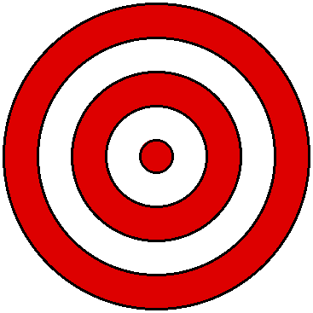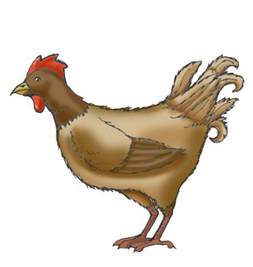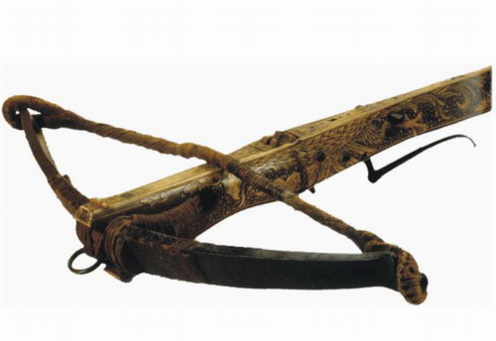Shooting gallery is a first person shooter game where you have a crossbow and targets.

You can also shoot Chickens! Which is very entertaining because they go flying!

You’re a character that gets a crossbow with endless bolts. You can aim and shoot targets however you cannot move from your coordinate on the map.

You shoot targets that have a bulls eye on them, the arrows stick into the targets and can potentially knock them over.